**THE CANE TOAD**

Adapted from http://toadshop.com/

Back in the 1930s, Australia was trying to deal with sugar cane beetles that were destroying their crops. In 1935, after some questionable research, someone thought to import about 100 cane toads from the Americas because they supposedly would devour these beetles. Researchers soon discovered the beetle population was not declining as planned but, instead, the population of cane toads started booming. It was observed that the toads couldn't jump high enough to catch the beetles and there was plenty of easier prey to get at their ground level.

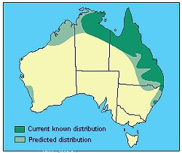To aggravate the cane toad problem, there are no natural predators of the toad in Australia. In fact, if one of Australia's many unique creatures decides to try to eat a toad, they themselves will die from the very deadly toxins found in the body of the toad. The cane toad has now become a pest all over Northern Australia -- the original 100-odd toads now have over 100 million descendants overrunning the country.

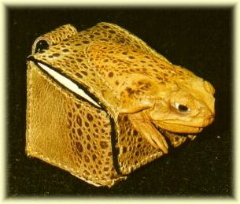The cane toads can live for 40 years, grow to 25 cm, and weigh up to 2.3 kg. Ranging in size from small to extra-large — think of a football with legs and a head — people are now becoming quite creative in ways of handling the “new” pest. In many tourist areas, cane toad leather products are sold as souvenirs since the skin of the cane toad is strong, tough and durable which results in great long-lasting gift items.

Finally, cane toads have been used for centuries by Chinese medicine in the treatment of cardiovascular diseases and cancer. There is talk of a new farming industry in Queensland where they would start "harvesting" cane toads in high volume for production of therapeutic medicines. If this outcome should ‘come to pass’ then the cane toad souvenir industry is unlikely to survive in its present form.

**'THE CANE TOAD' WORD LIST**

|  |  |  |
| --- | --- | --- |
| **ENGLISH** | | **SLOVENE** |
|  | sugar cane |  |
|  | crops |  |
|  | questionable |  |
|  | supposedly |  |
|  | to devour |  |
|  | beetles |  |
|  | declining |  |
|  | booming |  |
|  | prey |  |
|  | to aggravate |  |
|  | predator |  |
|  | toxin |  |
|  | pest |  |
|  | descendant |  |
|  | leather |  |
|  | souvenir |  |
|  | durable |  |
|  | cardiovascular |  |
|  | to harvest |  |
|  | production |  |
|  | therapeutic |  |
|  | 'come to pass' |  |